ST. XAVIER’S COLLEGE

**(Affiliated to Tribhuvan University)**

Maitighar, Kathmandu



**Database Management System Assignment #12**

**Submitted by:**

Bikash Paneru  
013BSCCSIT012

**Submitted to:**

|  |  |
| --- | --- |
| Er. Sanjay Kumar Yadav Lecturer, St. Xavier’s College |  |

**Date of Submission: October 30, 2015**

**Database Concurrency Control**

**Purpose of Concurrency Control**

Concurrency control is a database management systems (DBMS) concept that is used to address conflicts with the simultaneous accessing or altering of data that can occur with a multi-user system. Concurrency control, when applied to a DBMS, is meant to coordinate simultaneous transactions while preserving data integrity. The Concurrency is about to control the multi-user access of Database.

**Two phase locking**

This locking protocol divides the execution phase of a transaction into three parts. In the first part, when the transaction starts executing, it seeks permission for the locks it requires. The second part is where the transaction acquires all the locks. As soon as the transaction releases its first lock, the third phase starts. In this phase, the transaction cannot demand any new locks; it only releases the acquired locks.

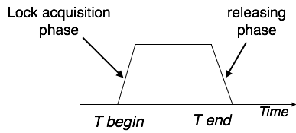

Two-phase locking has two phases, one is **growing**, where all the locks are being acquired by the transaction; and the second phase is shrinking, where the locks held by the transaction are being released.

To claim an exclusive (write) lock, a transaction must first acquire a shared (read) lock and then upgrade it to an exclusive lock.

**Time-stamp-based-protocols**

The most commonly used concurrency protocol is the timestamp based protocol. This protocol uses either system time or logical counter as a timestamp.

Lock-based protocols manage the order between the conflicting pairs among transactions at the time of execution, whereas timestamp-based protocols start working as soon as a transaction is created.

Every transaction has a timestamp associated with it, and the ordering is determined by the age of the transaction. A transaction created at 0002 clock time would be older than all other transactions that come after it. For example, any transaction 'y' entering the system at 0004 is two seconds younger and the priority would be given to the older one.

In addition, every data item is given the latest read and write-timestamp. This lets the system know when the last ‘read and write’ operation was performed on the data item.

**Commit Protocols**

In distributed data base and transaction systems a distributed *commit protocol* is required to ensure that the effects of a distributed transaction are atomic, that is, either all the effects of the transaction persist or none persist, whether or not failures occur. Several commit protocols have been proposed. These are variations of what has become a standard and known as the two-phase commit (2PC) protocol

**Two-phase Commit**

The database ensures the integrity of data in a distributed transaction using the **two-phase commit mechanism**. In the **prepare phase**, the initiating node in the transaction asks the other participating nodes to promise to commit or roll back the transaction. During the **commit phase**, the initiating node asks all participating nodes to commit the transaction. If this outcome is not possible, then all nodes are asked to roll back.

All participating nodes in a distributed transaction should perform the same action: they should either all commit or all perform a rollback of the transaction. The database automatically controls and monitors the commit or rollback of a distributed transaction and maintains the integrity of the **global database** (the collection of databases participating in the transaction) using the two-phase commit mechanism. This mechanism is completely transparent, requiring no programming on the part of the user or application developer.

The commit mechanism has the following distinct phases, which the database performs automatically whenever a user commits a distributed transaction:

| **Phase** | **Description** | |
| --- | --- | --- |
| Prepare phase | | The initiating node, called the **global coordinator**, asks participating nodes other than the commit point site to promise to commit or roll back the transaction, even if there is a failure. If any node cannot prepare, the transaction is rolled back. |
| Commit phase | | If all participants respond to the coordinator that they are prepared, then the coordinator asks the commit point site to commit. After it commits, the coordinator asks all other nodes to commit the transaction. |
| Forget phase | | The global coordinator forgets about the transaction. |

**Index Locking**

In databases an *index* is a data structure, part of the database, used by a database system to effectively navigate access to *user data*. Index data are system data distinct from user data, and consist primarily of pointers. Changes in a database (by insert, delete, or modify operations), may require indexes to be updated to maintain accurate user data accesses. **Index locking** is a technique used to maintain index integrity. A portion of an index is locked during a database transaction when this portion is being accessed by the transaction as a result of attempt to access related user data. Additionally, special database system transactions (not user-invoked transactions) may be invoked to maintain and modify an index, as part of a system's self-maintenance activities. When a portion of an index is locked by a transaction, other transactions may be blocked from accessing this index portion (blocked from modifying, and even from reading it, depending on lock type and needed operation). Index Locking Protocol guarantees that Phantom Phenomenon won't occur. Index locking protocol states:

* Every relation must have at least one index.
* A transaction can access tuples only after finding them through one or more indices on the relation
* A transaction Ti that performs a lookup must lock all the index leaf nodes that it accesses, in S-mode, even if the leaf node does not contain any tuple satisfying the index lookup (e.g. for a range query, no tuple in a leaf is in the range)
* A transaction Ti that inserts, updates or deletes a tuple ti in a relation r must update all indices to r and it must obtain exclusive locks on all index leaf nodes affected by the insert/update/delete
* The rules of the two-phase locking protocol must be observed.

**Lock Granulating**

It deals with the cost of implementing locks depending upon the space and time. Here, space refers to data structure in [DBMS](http://ecomputernotes.com/fundamental/what-is-a-database/advantages-and-disadvantages-of-dbms) for each lock and time refers to handling of lock request and release.

The cost of implementing locks depends on the size of data items. There are two types of lock granularity:

• Fine granularity

• Coarse granularity

Fine granularity refers for small item sizes and coarse granularity refers for large item Sizes.

Here, Sizes decides on the basis:

• a database record

• a field value of a database record

• a disk block

• a whole file

• the whole database

If a typical transaction accesses a small number of records it is advantageous that the data item granularity is one record. If a transaction typically accesses many records of the same file it is better to have block or file granularity so that the transaction will consider all those records as one data item.

[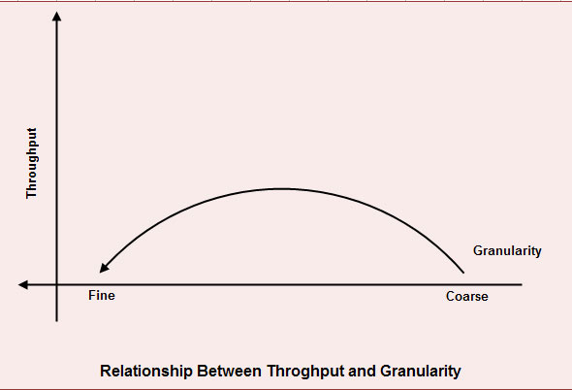](http://ecomputernotes.com/images/RELATIONSHIP-BETWEEN-THROUGHOUT-AND-GRAvity.jpg)

A too-fine granularity will increase the frequency of locks requests and locks releases, which therefore will add additional instructions. You must locate a balance between a too-fine and too-coarse granularity. The figure shows the relation between the throughput and the granularity of locks.

This illustration is a simple two axis chart. The vertical, or y axis, represents throughput.

The horizontal, or x axis, represents granularity going from fine to coarse as it moves out on the scale. An elongated bell curve shows the relationship of granularity on throughput. As granularity goes from fine to coarse, throughput gradually increases to a maximum level and, then slowly starts to decline. It shows that a compromise in granularity is necessary to reach maximum throughput.

**Time-stamp ordering multi version concurrency control**

The timestamp-ordering protocol ensures serializability among transactions in their conflicting read and write operations. This is the responsibility of the protocol system that the conflicting pair of tasks should be executed according to the timestamp values of the transactions.

* The timestamp of transaction Ti is denoted as TS(Ti).
* Read time-stamp of data-item X is denoted by R-timestamp(X).
* Write time-stamp of data-item X is denoted by W-timestamp(X).

Timestamp ordering protocol works as follows −

* **If a transaction Ti issues a read(X) operation −**
  + If TS(Ti) < W-timestamp(X)
    - Operation rejected.
  + If TS(Ti) >= W-timestamp(X)
    - Operation executed.
  + All data-item timestamps updated.
* **If a transaction Ti issues a write(X) operation −**
  + If TS(Ti) < R-timestamp(X)
    - Operation rejected.
  + If TS(Ti) < W-timestamp(X)
    - Operation rejected and Ti rolled back.
  + Otherwise, operation executed.

**Deadlock handling-detection and resolution**

**Deadlock Prevention**

To prevent any deadlock situation in the system, the DBMS aggressively inspects all the operations, where transactions are about to execute. The DBMS inspects the operations and analyzes if they can create a deadlock situation. If it finds that a deadlock situation might occur, then that transaction is never allowed to be executed.

There are deadlock prevention schemes that use timestamp ordering mechanism of transactions in order to predetermine a deadlock situation.

**Wait-Die Scheme**

In this scheme, if a transaction requests to lock a resource (data item), which is already held with a conflicting lock by another transaction, then one of the two possibilities may occur −

* If TS(Ti) < TS(Tj) − that is Ti, which is requesting a conflicting lock, is older than Tj − then Ti is allowed to wait until the data-item is available.
* If TS(Ti) > TS(tj) − that is Ti is younger than Tj − then Ti dies. Ti is restarted later with a random delay but with the same timestamp.

This scheme allows the older transaction to wait but kills the younger one.

**Wound-Wait Scheme**

In this scheme, if a transaction requests to lock a resource (data item), which is already held with conflicting lock by some another transaction, one of the two possibilities may occur −

* If TS(Ti) < TS(Tj), then Ti forces Tj to be rolled back − that is Ti wounds Tj. Tj is restarted later with a random delay but with the same timestamp.
* If TS(Ti) > TS(Tj), then Ti is forced to wait until the resource is available.

This scheme, allows the younger transaction to wait; but when an older transaction requests an item held by a younger one, the older transaction forces the younger one to abort and release the item.

In both the cases, the transaction that enters the system at a later stage is aborted.

**Deadlock Avoidance**

Aborting a transaction is not always a practical approach. Instead, deadlock avoidance mechanisms can be used to detect any deadlock situation in advance. Methods like "wait-for graph" are available but they are suitable for only those systems where transactions are lightweight having fewer instances of resource. In a bulky system, deadlock prevention techniques may work well.

**Wait-for Graph**

This is a simple method available to track if any deadlock situation may arise. For each transaction entering into the system, a node is created. When a transaction Ti requests for a lock on an item, say X, which is held by some other transaction Tj, a directed edge is created from Ti to Tj. If Tj releases item X, the edge between them is dropped and Ti locks the data item.

The system maintains this wait-for graph for every transaction waiting for some data items held by others. The system keeps checking if there's any cycle in the graph.

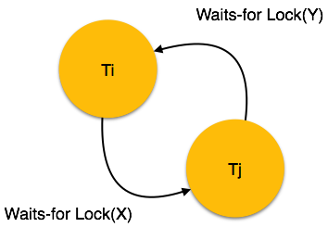

Here, we can use any of the two following approaches −

* First, do not allow any request for an item, which is already locked by another transaction. This is not always feasible and may cause starvation, where a transaction indefinitely waits for a data item and can never acquire it.
* The second option is to roll back one of the transactions. It is not always feasible to roll back the younger transaction, as it may be important than the older one. With the help of some relative algorithm, a transaction is chosen, which is to be aborted. This transaction is known as the **victim** and the process is known as **victim selection**.